CO2FIX V2.0

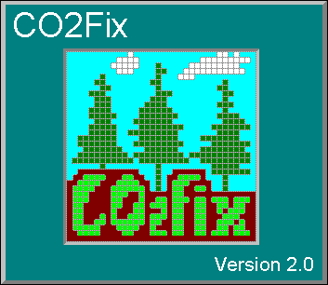
- manual of a model for quantifying carbon sequestration in forest ecosystems and wood products

G.J. Nabuurs, J.F. Garza-Caligaris, M. Kanninen, T. Karjalainen, T. Lapvetelainen, J. Liski, O. Masera, G.M.J. Mohren, A. Pussinen, and M.J. Schelhaas






ALTERRA Report xx
Wageningen, 2001

DISCLAIMER

By having clicked on the ‘I agree’ button when you registered for CO2FIX you have agreed to the license conditions mentioned below.
The CO2FIX V2.0 (for Microsoft® Windows) can be downloaded from the World Wide Web free of charge and exclusively for the purpose of research, education or real-life application to carbon sequestration projects. It may not be distributed to third parties, other than by downloading the original software from the Web. If you use this program, the credit for both the model and the Windows program should be cited in an explicit acknowledgement in papers, reports or books that result directly or indirectly from the utilisation of the program. The acknowledgement should read: ‘This study /paper/report was based on an application of the CO2FIX V 2.0 software as developed by the CASFOR project by G.J. Nabuurs, J.F. Garza-Caligaris, M. Kanninen, T. Karjalainen, T. Lapvetelainen, J. Liski, O. Masera, G.M.J. Mohren, A. Pussinen, and M.J. Schelhaas of ALTERRA, UNAM, CATIE and EFI’.
The programme may only be used in the form as downloaded. Further modifications and further developing the model can only be done after having consulted G.J. Nabuurs at ALTERRA in The Netherlands.
We appreciate that reprints of articles citing the program be sent to
G.J Nabuurs, ALTERRA P.O Box 47 , NL 6700 AA Wageningen, The Netherlands.

Except for the enclosed case study forest types, the user of CO2FIX is solely responsible for the quality of parameterisation data. Neither the authors of the model, nor those of the Windows version assume responsibility for damages caused directly or indirectly from the use of the program or by the application of results derived from it.

When using the model reference should always be made to:
This manual:
G.J. Nabuurs, J.F. Garza-Caligaris, M. Kanninen, T. Karjalainen, T. Lapvetelainen, J. Liski, O. Masera, G.M.J. Mohren, A. Pussinen, M.J. Schelhaas. 2001. CO2FIX V2.0 – manual of a model for quantifying carbon sequestration in forest ecosystems and wood products. ALTERRA Report xx. Wageningen The Netherlands x p.
and to:
Masera, O., J.F. Garza-Caligaris, M. Kanninen, T. Karjalainen, G.J. Nabuurs, A. Pussinen, and B.J. de Jong, 2001. Modeling Carbon sequestration in Afforestation and Forest Management Projects: The CO2fix V.2 Approach. (in prep.)

CASFOR Team,
Wageningen, Patzcuaro, Turrialba, Joensuu 30 October 2001

Dr. ir. Gert-Jan Nabuurs, G.M.J. Mohren & ir. M.J. Schelhaas
ALTERRA
g.j.nabuurs@alterra.wag-ur.nl

Dr. Omar Masera & Jose Garza-Caligaris
Laboratorio de Bioenergía, Instituto de Ecología Universidad Nacional Autónoma de México (UNAM)
omasera@oikos.unam.mx

Dr. Markku Kanninen
Centro Agronómico Tropical de Investigación y Enseñanza (CATIE)
Costa Rica
Kanninen@catie.ac.cr

Dr. Timo Karjalainen, Ari Pussinen, Jari Liski & Tuija Lapvetelainen
European Forest Institute, (EFI)
Finland
Timo.karjalainen@efi.fi

Acknowledgements

The CO2FIX model V 2.0 was developed in the CASFOR project. CASFOR was financed through the EU INCO-DC programme (ERBIC18 CT98 0324). Additional funding was received from the Dutch Climate Change Research Programme of the Ministry of Agriculture, Nature Management and Fisheries. We like to thank Prof Riveill-Bounaga of the European Commission DG Research, for her support during the project.

CASFOR has a continuation in the period 2002-2005, aiming at a landscape level approach of the CO2FIX model, and closer connection to Kyoto Protocol related projects. This project will be led by the Wageningen University and Research Center, Silviculture and Forest Ecology Group.

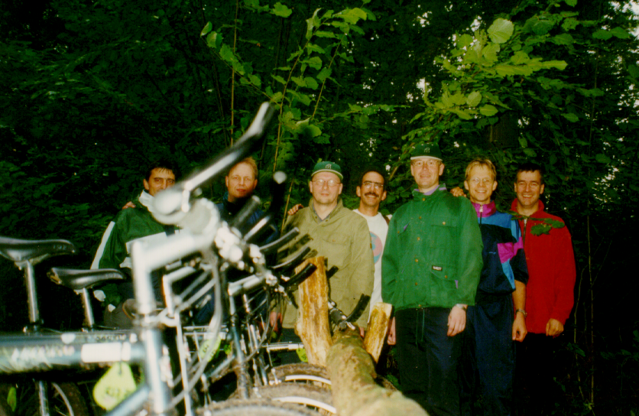
The CASFOR Team at a cycling event in The Netherlands. From left to right: Omar Masera, Timo Karjalainen, Markku Kanninen, Jose Garza-Caligaris, Ari Pussinen, Mart-Jan Schelhaas, and Gert-Jan Nabuurs

CONTENTS

DISCLAIMER 2
CONTENTS 5
1. INTRODUCTION 6
2. CONCEPTUAL DESCRIPTION 8
2.1. General description 8
2.2. Biomass module 9
2.3. Soil Module 19
2.4. Products module 21
3. MANUAL 25
3.1. Registration and downloading 25
3.2. Installation 25
3.3. Main menu and General parameters 25
3.4. Parameterising the biomass module 27
3.5. Parameterising the soil module 32
3.6. Parameterising the wood products module 35
3.7. Output 41
3.8. Troubleshooting 41
3.9. Accuracy of the carbon balances as simulated by CO2FIX V 2.0 42
4. ENCLOSED CASE STUDIES 44
REFERENCES 47

1. INTRODUCTION

In July 2001, further agreement was reached at COP VIb regarding implementation of the Kyoto Protocol. Clarification was given to the role that forests and forest management may play in reaching a nation’s emission reduction commitment. This agreement can be seen as the result of a long process of scientific and political discussions on the role of the global biosphere in the global carbon cycle, and it is one step further towards real-life implementation of carbon sequestration projects in forests and forest management.

Earlier on, the potential contribution that forests can provide to curbing the increase of atmospheric carbon dioxide had initiated many studies into the possibilities of enhancing and maintaining carbon sequestration of global forests. Options for enhancement and maintenance of the carbon sequestration are: stopping deforestation, expanding forest area, increasing the carbon stock in existing forests (including soils), increasing the use and life span of wood products, and using wood products as biofuels for substituting fossil fuels (Kauppi et al. 2001).

However, quantifying the likely results of the above-mentioned options is difficult because C sequestration in forests consists of stocks and fluxes in various compartments in the forest ecosystem as well as in the manufactured wood products. Management that focuses on enhancement of carbon in e.g. forest biomass therefore has an impact on soils and wood products as well. Also, study results are difficult to compare because of differences in the forest types, site types, management systems, monitoring methodology used, or because only parts of the carbon cycle of a forest ecosystem-wood products chain are regarded, or because different time scales are used.

To address these issues and provide insight in the temporal dynamics of carbon sequestration, CO2FIX V 1.0 was designed for even-aged monospecies stands (Mohren & Klein Goldewijk 1990, Nabuurs & Mohren 1995, Ordóñez 1998, De Jong et al 1998, Nabuurs and Schelhaas In press). Later, this version of CO2FIX was further developed into a windows based user friendly programme and released through the world wide web in June 1999. Since then 851 users from 75 countries have downloaded the software and applied it in several studies (Buford and Stokes 2000), or further developed it (Richards and Evans 2000). In the meanwhile further development of CO2FIX itself went on as well, now resulting in the release of Version 2.0 through the world wide web again. This version 2.0 is a hectare scale model which was improved on:

- the ability to simulate multi-species and uneven aged stands in multiple cohorts;
- the ability to parameterise the growth also by stand density;
- the ability to deal with inter cohort competition;
- allocation, processing lines, and end-of-life disposal of harvested wood;
- soil dynamics;
- the ability to deal with a wider variety of forest types including agro-forestry systems, selective logging systems, and post harvesting mortality;
- output viewing charts.

This report outlines the characteristics of this CO2FIX V 2.0 (Ch 2) and then continues with the manual itself (Chapter 3), and a short description of the five case study examples. The software including input files can be downloaded from the world wide web: http://www.efi.fi/projects/casfor

2. CONCEPTUAL DESCRIPTION

2.1. General description

CO2FIX V 2.0 is a carbon bookkeeping model that simulates stocks and fluxes of carbon in (the trees of) a forest ecosystem, the soil, and (in case of a managed forest), the wood products. It simulates these stocks and fluxes at the hectare scale with time steps of one year. For an extensive description of carbon dynamics in forest ecosystems, and the role of forests in the global carbon cycle see Kauppi et al. (2001).

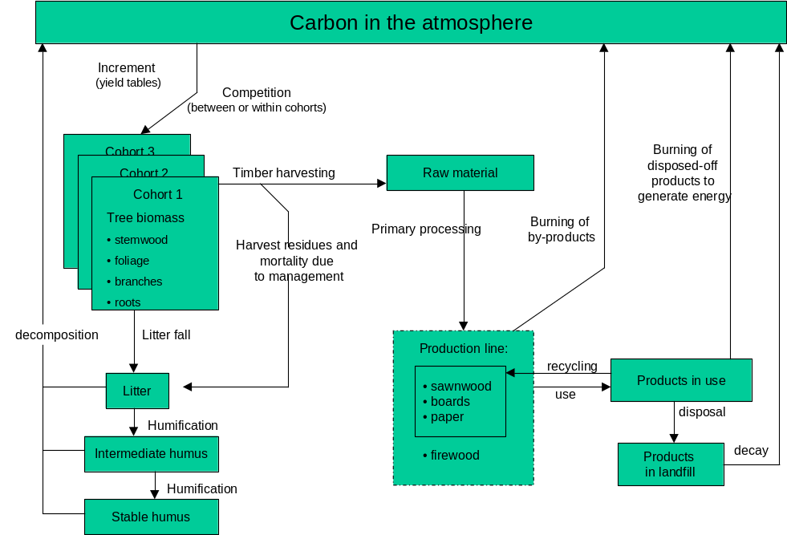

Figure 1. The compartments of CO2FIX V 2.0 .

2.2. Biomass module

The development of the new biomass module of the CO2FIX model aimed at offering a more flexible tool that can be applied to a wider variety of forest types. In addition to the single-species even-aged stands (of Version 1.2), it is now possible to model multi-species and uneven aged stands, e.g.:

- Tropical primary rainforest (logged or natural) with primary, intermediate and climax cohorts;
- Native mixed and un-even aged forests (e.g. mixed pine-oak forests);
- Multi-strata agroforestry and silvopastoral systems.

This kind of model needs to take into account the following processes:
- initial biomass, growth and mortality of each functional group (relative to standing biomass), and
- interactions within and between the functional groups.

The model developed here is a “cohort model” (Reed 1980), where each cohort is defined as a group of individual trees or as a group of species, which are assumed to exhibit similar growth, and which may be treated as single entities within the model (Vanclay 1989, Alder and Silva 2000).

Basic concepts

There are two basic approaches for modeling of growth of a forest:
- tree growth as a function of tree or stand age, and
- tree growth as a function of tree size or as function of stand basal area, volume or biomass.

CO2FIX V 2.0 allows the modelling through both approaches.
Re 1. In a situation where the age of the forest and/or trees is known the tree biomass growth is often modeled as a function of time, using growth functions, such as the Chapman-Richards function (Fig. 2):

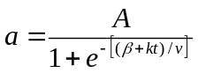 [1]

where
a = the attribute (e.g. stand biomass) at time t
A = the final value of the attribute (the maximum stand biomass) attained
t = time, and
β, k and v are the parameters.

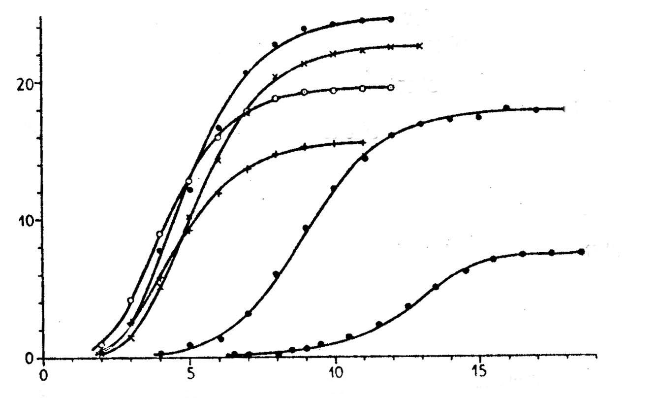

Figure 2. Schematic presentation of tree growth using the Chapman-Richards-function (Eqn. 1) in six cases with different growth characteristics.

In practice, and also in this software, the data for this biomass growth is given as the derivative of the Eqn. 1, i.e. in the form of current annual increment (CAI) of the stemwood volume (m³ ha⁻¹ yr⁻¹). This is because it is the data of tree growth most commonly available. (Fig. 3)

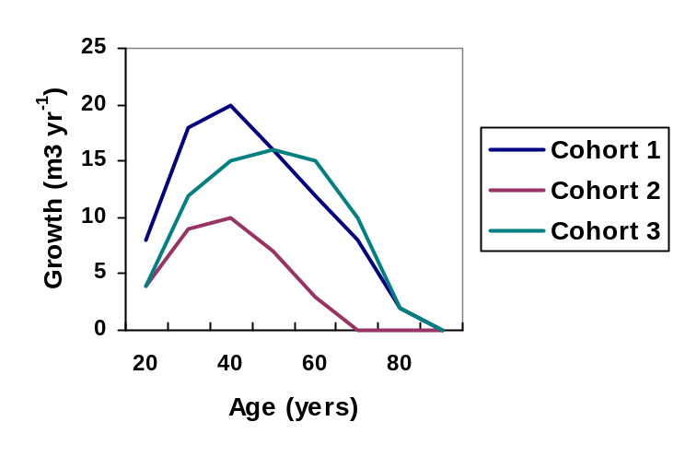
Figure 3. Current annual volume increment (CAI) of three cohorts in a forest stand as a function of cohort age.

Re 2. In a situation, where the tree/forest age is not known (e.g. the case of tropical primary and secondary forests), another approach is needed. A common method for modeling the growth in tropical primary or secondary forest is on the basis of diameter-increment functions. Vanclay (1989), for instance, used the following method:

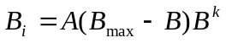 [2]

where
B_{i} = biomass increment
B = actual biomass
B_{max} = the maximum attainable biomass
A and k = parameter to be estimated.

The theoretical increment-diameter curves (Vanclay 1989) are shown in Fig 4. In Figure 5 the function of biomass growth as a function of stand biomass is shown.

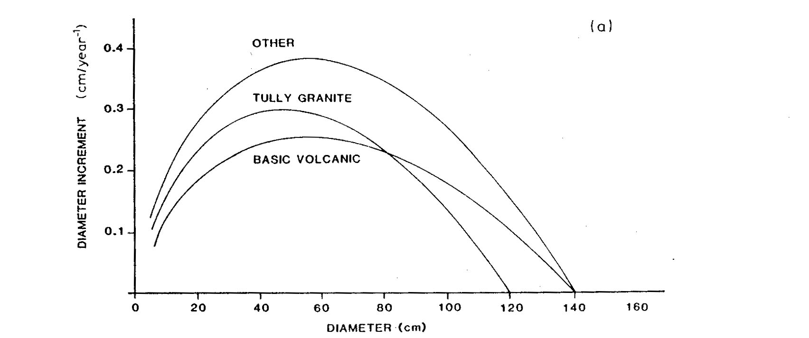

Figure 4. Diameter increment at the basal area of 20 m² ha⁻¹ in good sites (Vanclay 1989)

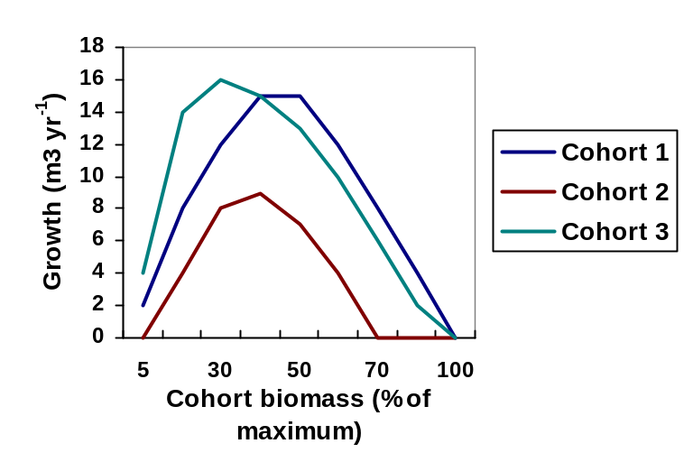

Figure 5. Current annual biomass increment (CAI) (m³ ha⁻¹ yr⁻¹) of three cohorts in a forest stand as a function of cohort biomass.

Biomass growth of foliage, branches, and roots

The growth of biomass of other stand components, i.e. branches, foliage, and roots is calculated as an additional fraction to the growth rate of the stem biomass.

Total biomass B_{t} = B_{s} + B_{f} + B_{b}+ B_{r}, where

B_{t} = Growth of total tree biomass
B_{s} = Growth of stem biomass
B_{f} = Growth of foliage biomass
B_{b} = Growth of branch biomass, and
B_{r} = Growth of root biomass

However, B_{f}, B_{b}, and B_{r} can be expressed as:

B_{f} = F_{f}*B_{s}
B_{b} = F_{b}*B_{s}
B_{r} = F_{r}*B_{s}.

Where:
F_{i} = biomass allocation coefficient (F_{f} for foliage, F_{b} for branches, F_{r} for roots).

In other words, the F_{i} is the biomass increment of the component i (foliage, ranches, roots) relative to the biomass increment of the stem (Fig. 6). It is expressed as a function of age or as a function of total biomass depending of the growth model in question.

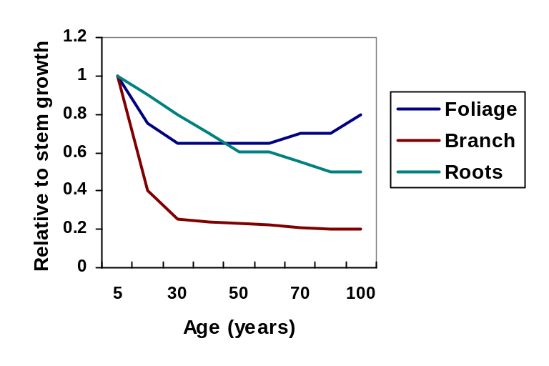

Figure 6. Example of the growth of biomass of foliage, branches and roots relative to stem biomass growth (biomass allocation coefficient) as a function of age.

Turnover

Turnover is the annual rate of mortality of the biomass component in question (foliage, branches, roots), i.e. the turnover rate 0.3 means that 33% of the total biomass of the component is converted to litter every year. The stem turnover rate is described by ‘mortality’ rate.

Mortality

The tree mortality of each cohort is being described in two ways:
- mortality due to senescence and density related competition, and
- mortality caused during and after logging operations.

Re a. In many cases, the mortality has been described as being constant over the rotation period (Shugart 1984). In CO2FIX V 2.0 the mortality is parameterised as a percentage of the standing biomass, however depending on the growth modelling approach chosen: 1) as function of tree or stand age, or 2) as a function of biomass over maximum biomass in the stand.

In the first case, it is assumed that all plants (trees) have a maximum age, and that the annual mortality (i.e. the probability of dying) increases when the age of the stand approaches the maximum age (Fig. 7). In some situations (e.g. Cohort 3 in the Fig. 7) there may also be high initial mortality which may be the case, for instance, in early and dense stages.

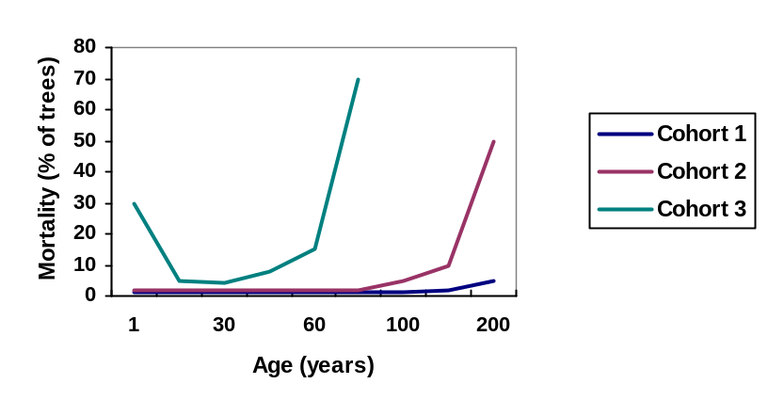
Figure 7. Mortality due to senescence of three cohorts parameterised as a function stand age. Note that these are hypothetical curves displaying very high chances of mortality.

In the second case, the mortality due to senescence is being parameterised as a function of tree size or as a function of biomass over maximum biomass. This is the case, when no age data is available – a typical situation for tropical natural forests. There are several functions that can be applied. For instance, for pioneers, the mortality is high at young age and then it decreases to a certain level, and finally when the stand approaches its maximum age, the mortality increases again (Vanclay 1989) (Fig. 8).
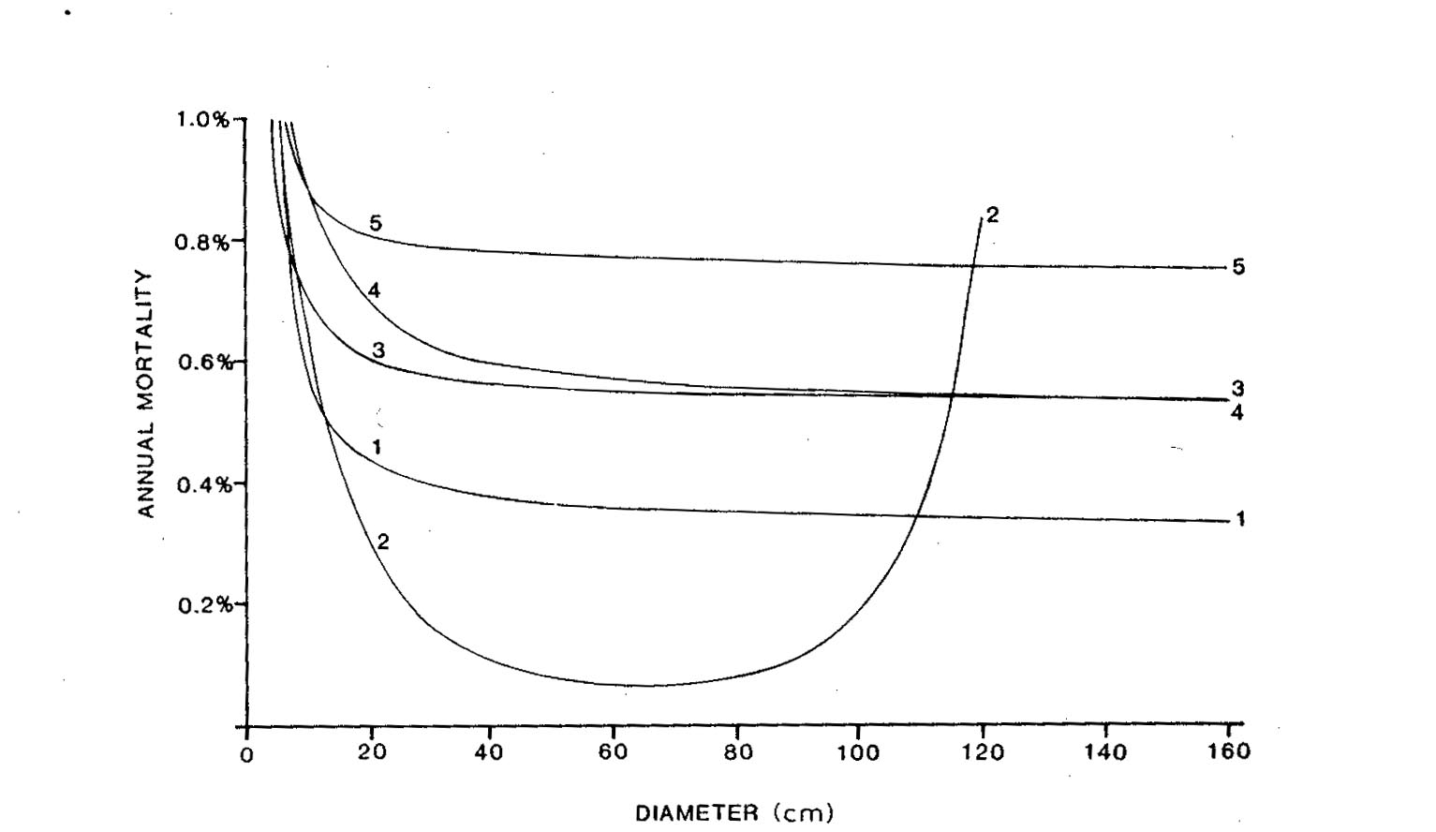

Figure 8. Mortality due to senescence of five cohorts as monitored as a function of mean diameter of each cohort (Vanclay 1989).

Re b. Forest logging operations cause damage to the remaining trees. This damage depends very much on the type of forest and the type of technology and methods used in logging. In tropical primary forests, when traditional logging methods are used, mortality due to logging damage can be very high, up to 40% of the remaining basal area (Alder and Silva 2000). The mortality due to logging damage is directly related to the intensity of logging, which can be expressed as the number of trees, basal area, volume, or biomass logged (Fig. 9).

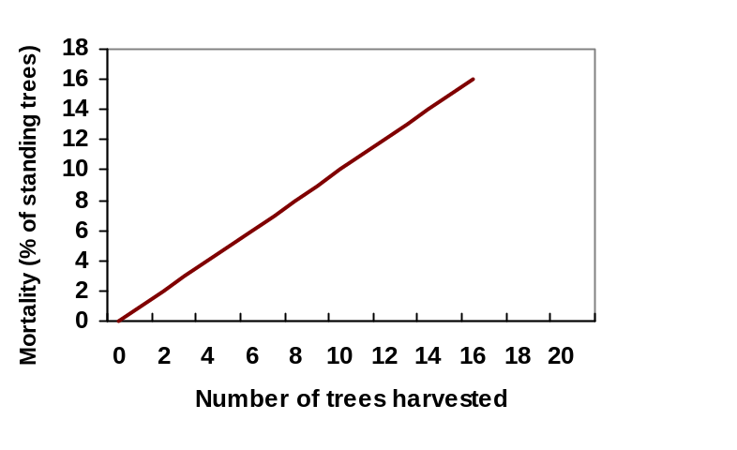
Figure 9. Mortality due to logging as a function of number of trees logged in Amazonian rain forest (Alder and Silva 2000).

In tropical forests, the logging may cause mortality during several years after the operation (Pinard and Putz 1997+). In many cases, the initial mortality is high during the first years after the logging, and the impact decreases gradually reaching zero in 10-20 years depending on the forest type and technology used (Pinard and Putz 1997). However, it has to be remembered that the damage also depends on the intensity of logging, i.e. on the biomass or volume of the trees removed (see the Fig. 9 above).

In this model, the mortality due to logging damage is parameterised as linear functions through time (years after logging) with three parameters: a) the initial mortality, b) duration of the damage, and c) intensity of the logging (Fig. 9). In Fig. 10, in cases one and two the mortality due to logging damage affects the remaining stand in a similar way through time, but depending on logging intensity (case one: 50 m³; case two: 20 m³). In case three low-intensity logging causes low initial mortality but the damage lasts long. In case four the initial mortality is low and the impact of damage is of short duration. For all cases: the cumulative percentages are the total damage to the stand. In case two this is 55%.

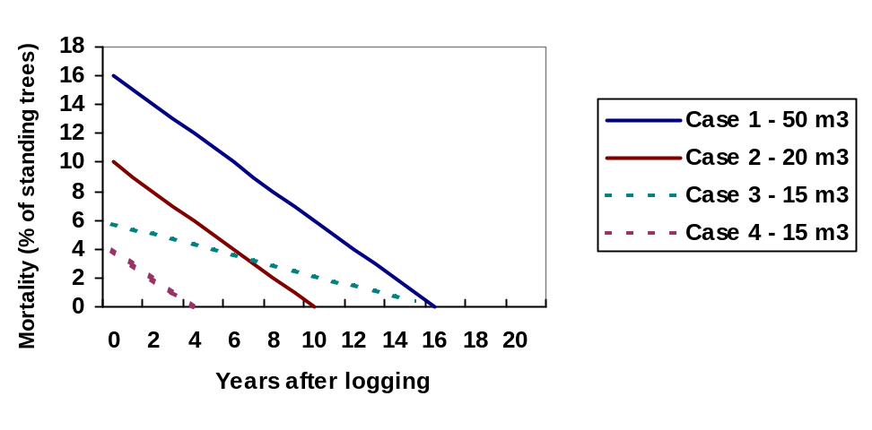
Figure 10. Mortality caused by damage from logging in four hypothetical cases.

The user has the following options for modeling the mortality due to logging damage:
- The mortality due to logging damage as a function of total biomass removed, i.e. the mortality of the remaining trees in all cohorts is uniform and proportional to the remaining biomass of each cohort (default).
- The mortality due to logging damage as a function of biomass removed from each cohort, i.e. the mortality of all the remaining trees in all the remaining cohorts depends on the characteristics and the degree of logging of the cohort logged.

Interactions (competition)

Tree growth in a stand is affected by the interactions caused by the presence of other trees. The major type of interactions is competition. For a cohort, the interaction can be caused by other individuals in the same cohort, or by individuals of other cohorts. Three types of interactions can be described: a) no competition, b) competition, c) synergic effects.

There are various ways of modeling the interaction. In gap models, this is usually done by using “growth modifiers” (Botkin et al., 1972). In this case, it is assumed that growth of the trees increases at a maximum rate under optimal conditions, and that the tree growth is then modified by biotic and abiotic environment. The modifier values range from 1 (no growth reduction) to 0 (no growth at all). In growth and yield models, the growth modifier is usually defined as a function of stand basal area or other variables indicating stocking density of he stand (Wykoff and Monserud, 1988, Hilt and Teck, 1988, Monserud and Sterba, 1996).

In this model, the interaction is being modeled using a parameter describing the influence of other individuals in the same cohort or the influence of other cohorts on the growth of the cohort in question. This parameter M (growth modifier) is being defined as function of total biomass of the stand (Fig 11).

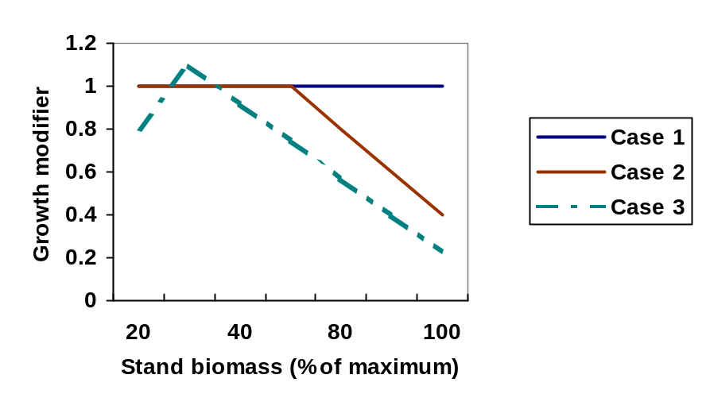

Figure 11. Growth modifier (M) as a function of total stand biomass (Mg ha⁻¹) in three cases.

In Fig. 11 we have three cases of interaction. Case 1 (M=1): no competition, i.e. no growth reduction occurs. This is the model default (it is assumed that the yield table data represent any kind of competition occuring). Case 2, where M= 1 until 50% of maximum biomass and then decreases from 1 to 0.4. In this case where there is no competition at low stand density and then the competition increases with increasing stand biomass. This is typical case for many forest stands. Case 3: M increases up to 1.2 and then decreases. This is the case of synergy – there is an optimal area in the range of stand biomass, e.g. a mixture of two cohorts, where the growth is higher in the mixture than in the case of each cohort alone. This is may be relevant in multi-species and multi-strata situations (e.g. Beer at al., 1990).

In practice, there is very little information and data on interactions especially in natural forests, mainly because in practical forestry situations these effects are embedded in other variables, such as the growth and mortality. That’s why the default value in this model is M=1 (no growth reduction).

The user of this model has two options for modeling the interactions between he cohorts and within the cohorts:
- Interactions (competition) of a cohort as a function of total stand biomass (total biomass of all cohorts in a stand), i.e. the interactions of this cohort are with all the cohorts combined, including the cohort in question (default)
- Interactions (competition) of a cohort as a function of biomass of each other cohort, i.e. the interactions of this cohort are defined with each other cohort separately

Management interventions (harvesting)

The user can define the management interventions thinnings and final cut for each cohort . The following information is needed for each cohort:
- Age at which the intervention takes place,
- Intensity of the intervention (fraction of cohort biomass removed),
- Allocation of the biomass removed to different “raw material” classes as slash, logwood and pulpwood.

In (b), the final cut means that the biomass removed is 100% of the total cohort biomass otherwise it is a thinning.

2.3. Soil Module

YASSO (Liski et al In prep) was chosen as a new approach for the soil compartment. The advantages are that this soil model calculates at the same time interval as CO2FIX, provides more information on dynamics in different soil pools than the previous soil module, and is not too data intensive. YASSO also combined the wish to have more relation to ‘real’ data with the wish of an understandable level of detail and dynamics. The YASSO model is suitable for non waterlogged mineral soils, and was mainly tested for temperate and boreal circumstances with a distinct growing season.

Decomposition of an active component

In this application of YASSO in CO2FIX, the soil model receives litter input (Mg C ha⁻¹ yr⁻¹) from living trees of each cohort from foliage (i_fo), fine roots (i-fr), branches (i_br), coarse roots (i-cr) and stems (i_st). Those inputs are quantified during the simulation in other parts of the CO2FIX model from turnover rates, natural mortality, management mortality, and logging slash. The distinction of different compartments in YASSO does not exactly follow the distinction between ect-organic and end-organic material as distinguishable in the field.

The litter decomposes or is transformed in three steps into stable organic matter (humus) (Figure 12).

The size of the litter pools (non-woody litter, fine woody litter and coarse woody litter, (x_nwl, x_fwl, x_cwl)) is determined by inputs from various sources of litter minus the fractionation rate per pool (a_{i}). These fractionation rates together with litter quality classes determine the proportions (c_{i}) that are allocated to solubles, holocellulose, and lignin like compounds. Each pool of solubles, cellulose and lignin thus receives inputs from the fractionated proportion of each litter pool times the share in each litter pool (c_{i}) times the size of each pool. The pool of e.g. solubles then looses due to decomposition (k_{I}) , which results in both release to atmosphere and addition of material to the lignin-like pool (p_{i}) . From the soluble and cellulose compartments, the transfer is to the lignin-like compartment, from the lignin-like compartment to the first humus compartment and from the first humus compartment to the second humus compartment (Figure 2). From the second humus compartment, carbon is only released to the atmosphere.

The rates of the physical fractionation (ai) and the decomposition (ki) depend on annual mean temperature (T) and the difference between precipitation and potential evaporation from May to June(P-E):

ai(T, P-E) = 1 + (0.0937 * (T - 4)) + 0.00229((P - E) - (-50)) * a0 (1)

ki(T, P-E) = 1 + c * (0.0937 * (T - 4)) + 0.00229((P - E) - (-50)) * k0 (2)

These dependencies were established by re-analysing data on the decomposition of Scots pine needles across Europe (Berg et al. 1993) and are built into this version of the soil model. The reference rates, a0 and k0, have been determined for conditions where T = 4°C and P-E = -50 mm by adjusting mass loss rates to litter bag experiments (Berg. et al. 1982, Berg et al. 1984) and model-calculated soil carbon amounts to measured values (Liski and Westman 1995) and accumulation rates of soil carbon (Liski et al. 1998). Parameter c is for decreasing the temperature dependence of humus decomposition (Liski et al. 1999). It is equal to 0.6 for the first humus compartment, 0.36 for the second one and 1 for the other compartments.
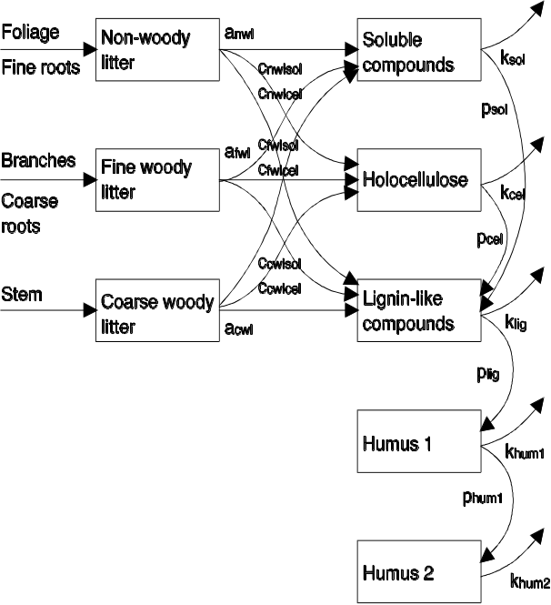

Figure 12 Flow chart of the soil submodel. The boxes represent carbon compartments, the arrows carbon fluxes with associated acronyms of parameters controlling the fluxes (Liski et al., In prep). Note that CO2FIX only distinguishes stems, branches, roots and foliage as litter input. All branches and roots together are regarded fine woody litter.
Required input data
As a minimum, the soil model requires data on mean annual temperature (MAT, °C), precipitation in the growing season (mm), and Potential Evapotranspiration in the growing season (PET, mm) for the site of study. For tropical circumstances the year-round precipitation, and the year-round Potential Evapotranspiration may be used.

For initialisation of all soil carbon stocks two alternative ways are provided: a) manually providing them, just like the climate parameters, b) automatically calculating equilibrium stocks from annual litter inputs of the past vegetation type. An indication of litter inputs can be derived from annual NPP figures for forest ecosystems: boreal forest around 3 Mg C ha⁻¹ yr⁻¹; temperate forest around 6 Mg C ha⁻¹ yr⁻1, tropical rainforest up to 11 Mg C ha⁻¹ yr⁻¹ (ref).

2.4. Products module

The principle of the products module is that it tracks the carbon from harvesting to final decay. It does that through several intermediate processing and allocation steps in the same year as harvesting, after which the carbon resides in the end-use commodities and disposed-off products (Figure 13). Carbon is released to the atmosphere when by-products are set-aside in the manufacturing phase, firewood is burned, or products in landfills decompose.

This module is based on a model developed and used before by Karjalainen et. al (1994) for modelling the carbon budget for the Finnish forest sector. More detailed version has been applied for the European forest sector (Karjalainen et al. 2001, Eggers 2001). The new wood products module provides the opportunity to the user to choose from either two sets of default parameters (high processing and recycling efficiency or low processing and recycling efficiency) or alternatively modify those parameters based on own data.

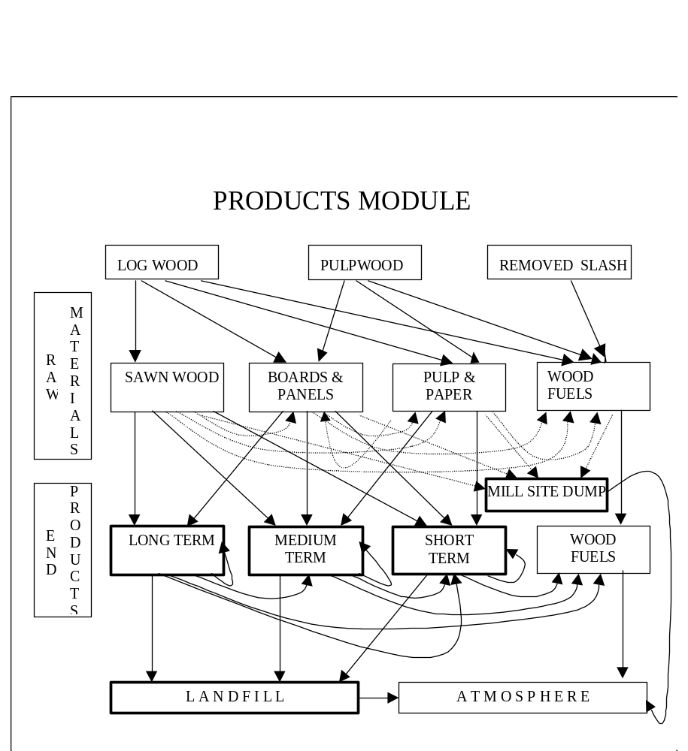

Figure 13. Outline of the wood products module. Arrows show flows of carbon between different phases of manufacturing and life span (from removed biomass from forest to atmosphere) and bolded boxes (long term products, medium term products, short term products, mile side dump and landfill) are stocks of carbon. Dashed lines describe process losses during manufacturing.

Raw materials stage

Here the model allocates the harvested biomass (either stems or branches that received their initial allocation in the biomass module) to be used for different commodities in the following steps:
Initial allocation:
- Fraction of log wood to be used for sawn wood, boards & panels, pulp & paper and firewood (energy)
- Fraction of pulpwood to be used for boards & panels, pulp & paper and firewood (energy).

Processing losses:
In the primary processing (e.g. cutting up logs to sawnwood) part of the raw material is lost and these by-products are used in other production lines: boards, pulp and paper, or wood fuel. Distinguished are:
- Fraction of sawn wood lost and reprocessed as boards, pulp & paper, wood fuel, or dumped at the mill site;
- Fraction of boards & paper lost and reprocessed as pulp & paper, wood fuel, or dumped at the mill site;
- Fraction of pulp & paper to be lost and reprocessed as wood fuel, or dumped at the mill site;
- Fraction of fire wood dumped at the mill site.

End products

In the end-products stage, the allocation of the commodities to different categories of use is specified (long term, medium, and short term use)
- Fraction of sawn wood to be used for long, medium and short term products
- Fraction of boards & panels to be used for long, medium and short term products
- Fraction of pulp & paper to be used for medium and short term products
- 100% of wood fuel will be used for short term products

Life span for products in use
An exponential discard over time is used in CO2FIX V 2.0 (Figure 14). This is specified by a fraction of the total stock of carbon in that products group that is disposed off every year. This is usually named the life time of a product, but is parameterised in CO2FIX as the inverse of the annual fraction discarded.

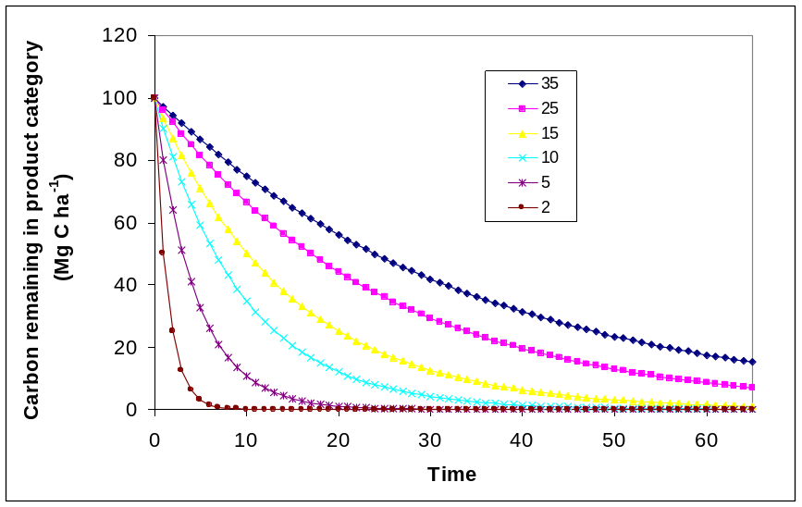

Figure 14. Discarding curves of carbon in end use products as simulated by CO2FIX for different ‘life times’.

Final allocation

Discarding of products can occur as recycling, using the wood as fire wood, or dumping the wood on a landfill. Recycling can be done to various end use categories again to which the life times as given in Figure 14 apply again, while for the decay on the landfill the same type of curve is used as given in Figure 14, but in this case resulting in release of carbon .

3. MANUAL

3.1. Registration and downloading

The minimum requirements for installing the program on your personal computer are: Intel 80386 processor, 4 MB RAM memory, 4 MB free space on the hard disk and any Win32 operating system previously installed. The software can be found on the world wide web on the site: http://www.efi.fi/projects/casfor/
Go to ‘CO2FIX-model V 2.0’ and after reading the disclaimer and completely filling out the registration form (including your email address) click ‘I agree’. A response email is automatically send to you instantly. It gives the URL where you can download the software. Go to that URL and start the download (CO2FIX V2.0 installer.exe) to a local directory e.g. C:\temp.

3.2. Installation

Execute the ‘CO2FIX V2.0 installer.exe’ and follow instructions in the install shield. Successful installation will result (amongst others) in a CO2FIX executable and a sub directory called ‘Samples’ with the five case studies. Furthermore a ‘Pet.xls’ file will be there.

3.3. Main menu and General parameters

To start double click the CO2FIX icon. The following window will show:

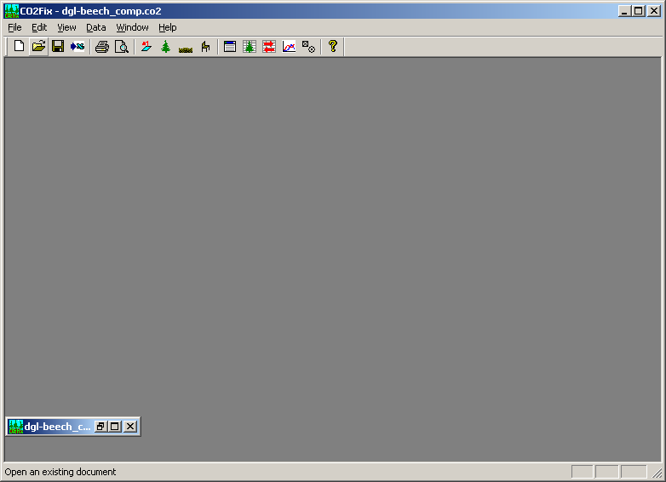

From left to right the icons show (alternatively the drop down menus ‘File’, ‘Edit’, etc can be used as well):
- Six standard windows icons;
- Four icons for the four main menus for parameterisation (parameters, biomass, soil and products);
- ‘New window’ icon that allows you to open multiple case studies at the same time;
- ‘View carbon stocks table’ icon to generate a table that shows all carbon stocks;
- ‘View flow table’ icon to generate a table that shows all carbon fluxes;
- ‘View carbon stocks chart’ icon to view simple ready-made charts of the output,
- ‘View options’ icon to select alternatives for the ready-made charts, and
- ‘About’ icon.

The first step consists of the creation of a new case study, or of opening an already existing one. When you choose a ‘new’ case study, and always hereafter when closing a parameterisation screen with the ‘Apply’ or ‘OK’ button, immediately a run is carried out based on the data inserted so far. So, when you have chosen for a new case study, one line of output with zero’s is created in a further empty carbon stocks table.

From now on, we will follow the example case study No. 2: mixed evenaged stand of Douglas-fir and beech.

The ‘parameters’ dialogue screen allows for inserting main input data to describe the case study, and the simulation methods chosen. Furthermore, origin of data can be given in ‘Comments’.

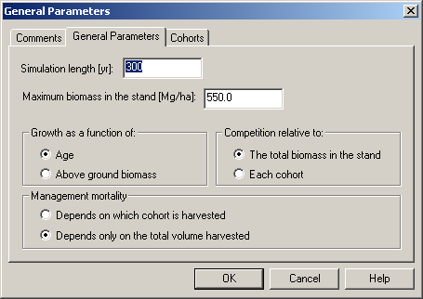
Figure 15. General parameters screen, in main menu ‘general parameters’

As a guidance to maximum biomass data, Table 1 is provided.

Table 1. Current average standing biomass (tonnes dry matter per ha) in different biomes of the world (Watson et al. 2000)
Biome | Current average dry matter content
tropical forests | 241
temperate forests | 113
boreal forests | 128
tropical savannas | 59
temperate grasslands | 14
deserts | 4
tundra | 13
wetlands | 86
croplands | 4

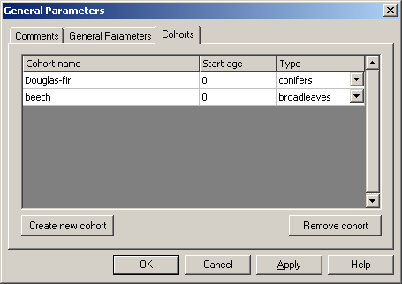

Figure 16. Cohorts screen in main menu ‘general parameters’

The cohorts screen allows to define the number of cohorts that form the stand, the starting age, and whether it is a coniferous or broadleaved species.

3.4. Parameterising the biomass module

The biomass main menu consists of the tabs as given in Figure 17. The first four tabs are for parameterising stems, foliage, branches and roots. Then tabs are given for Mortality, competition, management mortality, and thinning-harvest.

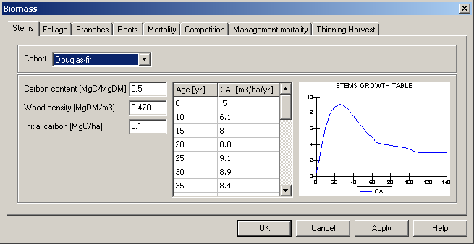
Figure 17. Stems parameterisation screen in main menu ‘biomass’

In Figure 17, the age related current annual increment parameterisation option is given. For each age a stem volume increment needs to be given. In addition, the carbon content of dry matter, the basic wood density (dry matter per fresh volume, see Table 2), and any carbon on site initially needs to be given. The latter is mainly the case when simulations do not start at age is 0.

Table 2. Basic wood densities for some tree species

Tree species | Basic wood density  (kg dry matter m⁻³) |  | Basic wood density  (kg dry matter m⁻³)
Abies | 450 | Pinus pinaster | 510-600
Acer | 560 | Pinus strobus | 400
Alnus | 510 | Pinus sylvestris | 480-500
Betula | 670 | Populus | 430-450
Carpinus betulus | 740-770 | Prunus | 620-630
Castanea sativa | 510-600 | Pseudotsuga menziesii | 540
Fagus sylvatica | 690-720 | Quercus | 690-700
Fraxinus | 670-690 | Salix | 430-500
Juglans | 640-680 | Thuja plicata | 370
Larix decidua | 540 | Tilia | 560
Larix kaempferi | 480 | Tsuga | 450-470
Picea abies | 420-450 | Ulmus | 510-700
Picea sitchensis | 440-450

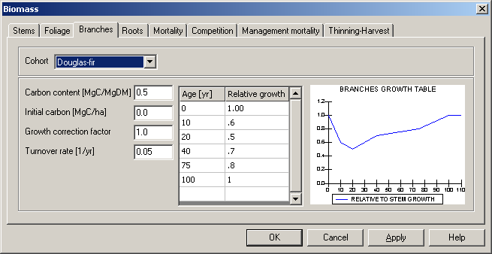
Figure 18. Branches parameterisation screen in main menu ‘biomass’

Three additional tabs for the three other tree compartments are then given. For each cohort the allocation to these compartments needs to be given. It is parameterised as additional to the allocation to stems, but relative to the stems dry matter growth rate. Very often in young trees most of the NPP is allocated to roots, branches and foliage. Therefore, parameterisation will often give a curve like in Figure 18. Together with turnover rates of this compartment (the fraction that dies every year) the stocks of carbon in the roots, branches and foliage are simulated. Only by checking these simulated stocks against e.g. biomass data, the parameterisation can be evaluated. Note that when you click ‘apply’ or ‘OK’ the simulation is immediately updated.

The growth correction factor makes it possible to apply a defined case study to a site of different fertility where allocation to roots and foliage may be higher. In that case it is avoided that the whole parameterisation of the complete case study needs to be done again.

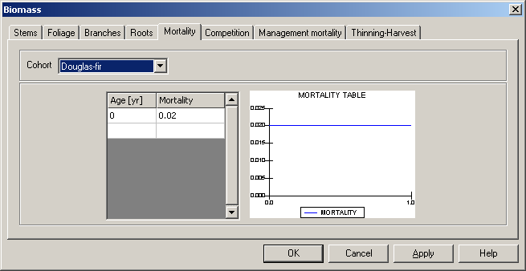
Figure 19. Mortality parameterisation screen in main menu ‘biomass’

Natural mortality can occur due to senescence or competition (see Ch 2) and is inserted here per age class as the fraction of the standing biomass that dies every year. In the example of Figure 19 the mortality was assumed to be stable (2%) throughout the age of the stand. If in ‘General parameters’ the growth was modeled as a function of biomass, then mortality is inserted here as well as a function of actual biomass over maximum biomass. In Figure 7, mortality was assumed to be much more dependent on the stage of the stand.

There are two ways of parameterising competition: A: competition relative to total biomass in the stand (Fig 20), and B: competition relative to each cohort (Fig 21).

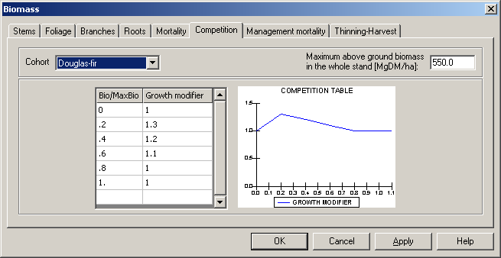

Figure 20. competition relative to total biomass in the stand
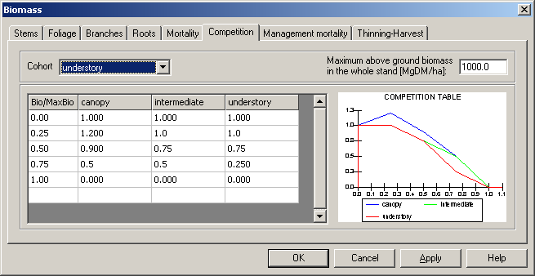

Figure 21. Competition relative to each cohort

As default for no competition ‘1’ is used. In case of A, competition is inserted as a function of actual biomass over maximum biomass for the chosen cohort in the top of the window, i.e. how this cohort is affected by the whole stand. In case of ‘B’ competition is also inserted as a function of actual biomass over maximum biomass but in such a way that reflects how the cohort in the top of the window is affected each of the others.

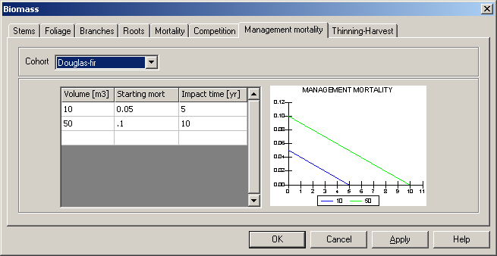

Figure 22. Management mortality

Management mortality is parameterised by cohort as the annual mortality in the whole stand (all cohorts equally) that is caused by logging in the cohort chosen in the top of the window. The mortality is parameterised as an annual fraction of the standing biomass, and for a certain impact time.

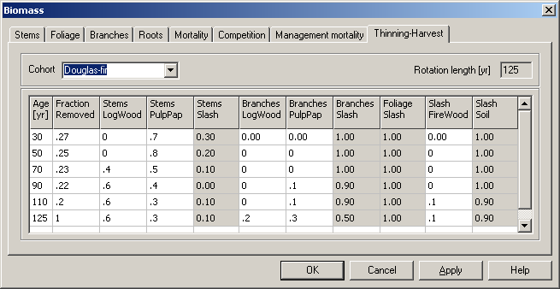

Figure 23. Thinning and final harvesting table

For each age that a thinning is carried out in the cohort chosen, the fraction removed is parameterised here. Furthermore, the first initial allocation of stems and branches over logwood, pulpwood and slash is parameterised, where Slash = 1- (logwood + pulpwood)

The foliage (and roots) are always totally allocated to slash. However, the sum of slash can partly be allocated to firewood representing non-commercial fuelwood collection.
A final harvest is indicated as a ‘1’ under ‘fraction removed’.

3.5. Parameterising the soil module

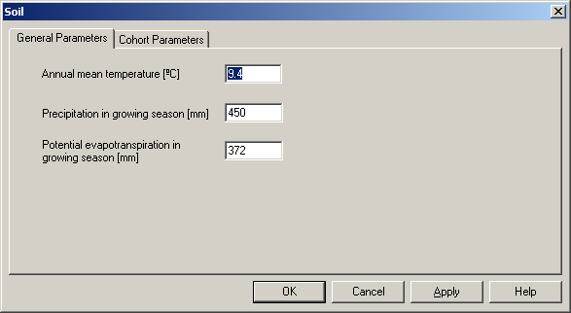
Figure 24. Main window for the soil module.

Dynamics in the soil compartment are driven by climatic circumstances of the site. These are characterised by mean annual temperature (MAT, °C), precipitation in the growing season (PREC, mm), and Potential Evapotranspiration in the growing season (PET, mm). MAT and PREC data may be found at http://www.worldclimate.com

Using the mean monthly temperatures from that website or from own data, the PET can be calculated using the ‘PET.xls’ file which was also installed through the CO2FIX install shield.

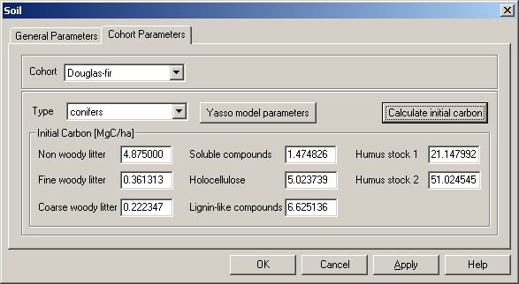
Figure 25. Soil initial stocks per compartment in the soil module.

For each cohort in the stand, the soil carbon stocks in each compartment must be initialised. This can be done through manually inserting available data in the window given in Figure 25, or initial stocks can be calculated by providing litterfall rates of the vegetation that was on the site before the current case study that you’re parameterising now. This latter option can be used through the window given in Figure 27. Those litterfall rates can again be derived by parameterising and running that previous vegetation/land-use in CO2FIX.

You can find some guidance on soil carbon stocks in various soil units in Table 3.

Table 3. Typical soil carbon contents (Batjes 1996)

Soil unit | Average carbon stock  (Mg C ha⁻¹) (0-100 cm depth) |  | Average carbon stock  (Mg C ha⁻¹) (0-100 cm depth)
Acrisols | 94 | Histosols | 776
Cambisols | 96 | Podsols | 242
Chernozems | 125 | Arenosols | 31
Podzoluvisols | 73 | Regosols | 50
Rendzinas | - | Solonetz | 62
Ferralsols | 107 | Andosols | 254
Gleysols | 131 | Rankers | -
Phaezoms | 146 | Vertisols | 111
Lithosols | - | Planosols | 77
Fluvisols | 93 | Xerosols | 48
Kastanozems | 96 | Yermosols | 30
Luvisols | 65 | Solonchaks | 42
Greyzems | 197
Nitosols | 84

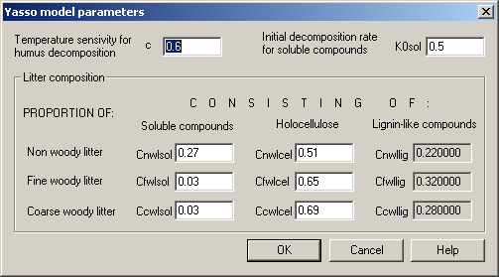
Figure 26. Soil module internal parameters.

The parameters in the window of Figure 26 are normally not altered by the user, except for the case where you are certain that you have better data. These parameters provide the proportion of solubles, holocellulose, and lignin-like compounds in each of the litter groups. Furthermore the temperature sensitivity parameter and the initial decomposition parameter are given (see chapter 2 for their function)

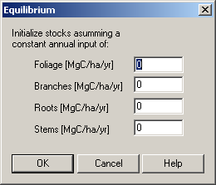
Figure 27. Window to initialise soil carbon stocks through litterfall rates of the previous land use.

3.6. Parameterising the wood products module

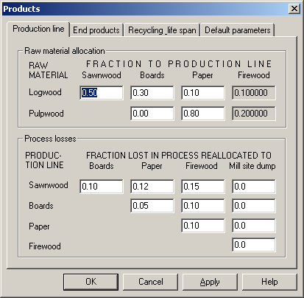

Figure 28. Parameterising the products module: raw material allocation and processing losses

The top part of the window in Figure 28 provides the possibility to allocate the logwood and pulpwood to the standard production systems.

Tables 4 and 5 show default parameters for high processing and recycling efficiency (e.g. highly integrated forest industry), and for low processing and recycling efficiency.

Table 4. Default, minimum and maximum parameter values for raw material allocation to different production lines for high processing and recycling efficiency system. The unit share, i.e. the sum of each row must be one.

 | Production line
 | Sawn wood |  | Boards |  | Paper |  | Firewood
Raw material | default | Min-max | default | Min-max | Default | Min-max | default | Min-max
Logwood | 0.8 | 0.5-1.0 | 0.15 | 0.2-1.0 | 0.05 | 0-0.1 | 0 | 0-0
Pulpwood | 0 | 0-0 | 0.05 | 0-0.4 | 0.9 | 0.8-1.0 | 0 | 0-0
Slash | 0 | 0-0 | 0 | 0-0 | 0 | 0-0 | 1.0 | 1.0-1.0

Table 5. Default, minimum and maximum parameter values for raw material allocation to different production lines for low processing and recycling efficiency system. The unit share, i.e. the sum of each row must be one.

 | Production line
 | Sawn wood |  | Boards |  | Paper |  | Firewood
Raw material | default | Min-max | default | Min-max | Default | Min-max | default | Min-max
Logwood | 1 | 1-1 | 0 | 0-0 | 0 | 0-0 | 0 | 0-0
Pulpwood | 0 | 0-0 | 0 | 0-0 | 0 | 0-0 | 0 | 0-0.2
Slash | 0 | 0-0 | 0 | 0-0 | 0 | 0-0 | 0 | 0-0.1

The bottom part of the window in Figure 28 provides the possibility to re-allocate processing losses to other commodities. These do not have to sum to ‘1’. E.g. in Figure 28 it says that of the logwood, 50% goes to the sawnwood line (top part of window). Out of that, 37% is lost in processing (bottom part of window, sum of top row). 10% is used in boards, 12% in paper, and 15% as firewood. See default parameters in tables 6 and 7.

Table6. Default, minimum and maximum parameter values for the amount of primary product and process losses in different standard production system for high processing efficiency.

PRODUCTION LOSSES DURING MANUFACTURING
 | To Sawn wood |  | To Boards |  | To Paper |  | To Firewood |  | To Mill site dump
Production  Line | Default | Min-max | default | Min-max | default | Min-max | default | Min-max | default | Min-max
Sawnwood | 0.4 | 0.2-0.6 | 0.1 | 0-0.3 | 0.3 | 0.1-0.5 | 0.2 | 0-0.3 | 0 | 0-0.6
Boards | 0 | 0-0 | 0.6 | 0.4-0.9 | 0.3 | 0-0.5 | 0.1 | 0.0-0.6 | 0 | 0-0.6
Paper | 0 | 0-0 | 0.1 | 0-0.2 | 0.6 | 0.3-0.9 | 0.3 | 0-0.4 | 0 | 0-0.4
Firewood | 0 | 0-0 | 0 | 0-0 | 0 | 0-0 | 0 | 0-0 | 1.0 | 1.0-1.0

Table 7. Default, minimum and maximum parameter values for the amount of primary product and process losses in different standard production system for low processing efficiency.

PRODUCTION LOSSES DURING MANUFACTURING
 | To Sawn wood |  | To Boards |  | To Paper |  | To Firewood |  | To Mill site dump
Production  Line | default | Min-max | default | Min-max | default | Min-max | default | Min-max | default | Min-max
Sawnwood | 0.3 | 0.2-0.5 | 0 | 0-0 | 0 | 0-0 | 0 | 0-0 | 0.7 | 0-0.9
Boards | 0 | 0-0 | 0.3 | 0.1-0.8 | 0 | 0-0 | 0.1 | 0-0.7 | 0.6 | 0-0.7
Paper | 0 | 0-0 | 0 | 0 | 0.25 | 0.2-0.5 | 0.25 | 0-0.8 | 0.5 | 0-0.8
Firewood | 0 | 0-0 | 0 | 0-0 | 0 | 0-0 | 0.9 | 0.5-1.0 | 0 | 0-0

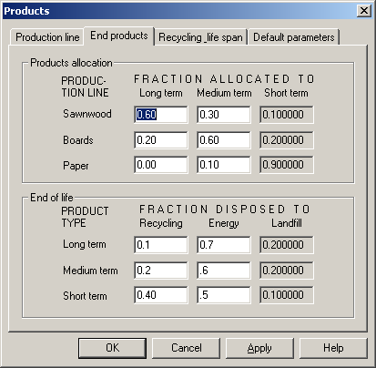
Figure 29. Parameterising the products module: life span allocation and end-of-life disposal

The top part of the window in Figure 29 provides the possibility to allocate the commodities to groups of life spans. These allocations will sum to 1 because short term = 1-( long term + medium term)

Table 8. Default, minimum and maximum parameter values for allocation of products to lifespan categories.
 | Fraction allocated to
 | Long term |  | Medium term |  | Short term
Product | Default | Min-max | Default | Min-max | Default | Min-max
Sawnwood | 0.5 | 0.3-0.8 | 0.25 | 0.1-0.5 | 0.25 | 0.1-0.4
Boards | 0.3 | 0.1-0.7 | 0.5 | 0.2-0.7 | 0.2 | 0.1-0.4
Paper | 0.01 | 0-0.05 | 0.1 | 0-0.2 | 0.89 | 0.8-1.0

The bottom part of the window in Figure 29 describes what disposal is applied to the products at end of life. The first option is recycling, i.e. the wooden material is reused in some function. The second option is to release products energy, i.e. to burn the products. The energy can be lost (open fire, no utilisation) or used in cooking, heating or power plant. The unit is share, i.e. the sum of each row is one.

Table 9. Default, minimum and maximum parameter values for shares of recycling, burning and landfill at disposal

 | Fraction disposed to
 | Recycling |  | Energy |  | Landfill
Life span | Default | Min-max | Default | Min-max | Default | Min-max
Long term | 0.3 | 0.1-0.4 | 0.1 | 0-0.3 | 0.6 | 0.4-0.8
Medium term | 0.1 | 0-0.4 | 0.1 | 0-0.4 | 0.8 | 0.6-1.0
Short term | 0.4 | 0.2-0.6 | 0.5 | 0.25-0.8 | 0.1 | 0-0.3

The top part of the window in Figure 30 allows parameterisation of the recycling between groups of life spans.

Table 10. Default, minimum and maximum parameter values for recycling to life spans for each original life span category.
 | Recycled to
 | Long term |  | Medium term |  | Short term
Original life span | Default | Min-max | Default | Min-max | Default | Min-max
Long term | 0.1 | 0-0.2 | 0.3 | 0-0.6 | 0.6 | 0.4-0.8
Medium term | 0 | 0-0 | 0.1 | 0-0.4 | 0.9 | 0.6-1.0
Short term | 0 | 0-0 | 0 | 0-0 | 1 | 1.0-1.0

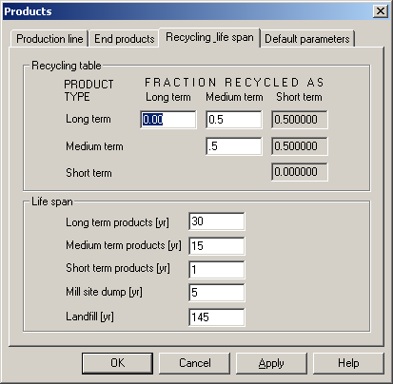
Figure 30. Parameterising the products module: way of recycling and life spans

The bottom part of the window in Figure 30 provides parameterisation of life spans. The life span of different lifespan categories varies in countries. The life span parameter itself describe the share of remaining products disposed each year. For example 15 means that 1/15=6.67% of remaining stock reaches the end of life each year.

Table 11. Default life spans

Stock | Life span yr
Long term products | 30
Medium term products | 15
Short term products | 1
Mill site dump | 5
Landfill | 145

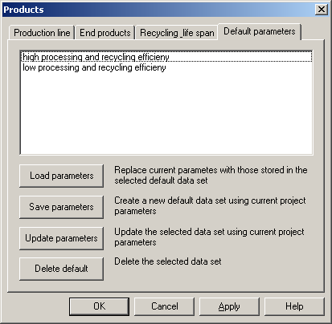
Figure 31. Parameterising the products module: choosing sets of parameters.

The window in Figure 31 allows to easily choose between set of parameters, and to load data from own sources.

3.7. Output

The main menu of CO2FIX has several options to deal with output. These are:
‘View carbon stocks table’ icon to generate a table that shows all carbon stocks;
- ‘View flow table’ icon to generate a table that shows all carbon fluxes;
- ‘View carbon stocks chart’ icon to view simple ready-made charts of the output,
- ‘View options’ icon to select alternatives for the ready-made charts.

Both of the tables can be exported to a flat text file that can be imported to e.g. Excel. The ready made charts can easily be altered through the ‘view options’ icon. This allows to view stocks of either carbon, dry weight, volume or current annual increment for total biomass, by cohort, or for the soil and products compartment.

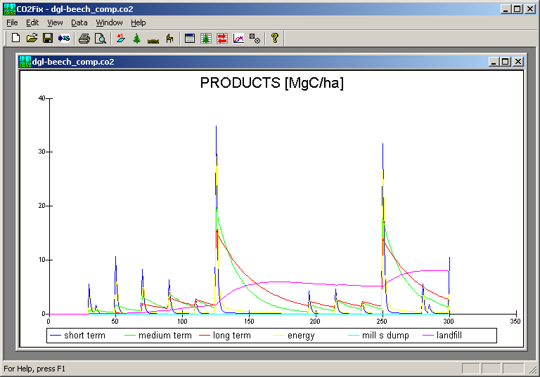
Figure 32. Example of a ready-made view option showing carbon stocks in each of the wood products compartments.

3.8. Troubleshooting

1. Clicking the URL in the instant reply email that you got after registering gave the response that the page cannot be found: You may have waited longer than 24 hours with downloading since the registration you did. In this case just register again. The instant reply email that you will get, will give you the new URL from where to download the software.

2. Downloading took too long, and your connection failed. Just try again on
a more quiet time of the day.

3. Clicking the URL in the instant reply email that you got after registering gave the response that the page cannot be found: The URL in the instant reply email that you got after registering may have truncated the URL address. Make the message box wide enough so that the whole URL is on one line.

4. If you want to make a net annual flux graph for your case study, you can do that by exporting the 'view flow table' to Excel. Then add to the very right of the columns, an extra column. This can be called net annual flux and is calculated by substracting the most right hand column 'atmosphere losses' from the one-but the most right hand column 'atmosphere increments'.

3.9. Accuracy of the carbon balances as simulated by CO2FIX V 2.0

Errors in forest resource projections (and thus C balances) have two main sources (Kangas 1997): a. the stochastic character of the estimated model coefficients; b. measurement errors in the data or lack of data used for model construction;
Re a. In nature, an enormous variability occurs. This variability still exists within one clearly defined forest type and is the result of e.g. growth variation between years caused by weather circumstances, intra-species genetic differences, and site quality variation. This natural variability is not captured by CO2FIX because it very much relies on fixed input data from yield tables that can be seen as some sort of complete, and perfectly managed forests. Other stochastic events are management irregularity and risks caused by e.g. storm and fire. These events are not captured either. Furthermore natural variability occurs in carbon content of dry matter, basic wood density, litter and humus decomposition rates.

When parametrising CO2FIX this variability is usually dealt with by trying to find the average or median value of a parameter. Only when multiple runs are carried out in which the natural variability in e.g. growth rates, carbon content, and humus decomposition is captured, then CO2FIX provides insight in this type of uncertainty.

Re b. CO2FIX relies heavily on net annual increment data from yield tables1. These tables are based on long-term measurement series in permanent plots and or forest inventories. In these measurement series, errors and/or bias can occur. However these errors are usually very small. Both forest inventories and yield tables are generally seen as very reliable. Tomppo (1996) gives standard errors of some characteristics of the National Forest Inventory in Finland: forest land area 0.4%, growing stock 0.7%, and increment 1.1%. However, where input data for CO2FIX rely on few measurements or a single series, uncertainty in the predictions will increase very much. This type of uncertainty especially exists in the soil pools.

Van der Voet (in: Nabuurs & Mohren 1993) carried out an uncertainty analysis of the model CO2FIX. He specified input uncertainties in the form of simultaneous input distributions for an even-aged forest type. The 100 simulations with randomly chosen values of input gave an average CTOTAV of 316 Mg C ha-1. The standard deviation was 12% and the 95% confidence interval was 254 - 403 Mg C ha-1. He concluded that it was mainly the litter and humus coefficients and the carbon content that determined this uncertainty, but in general it was mainly the natural variability rather than a lack of data that determined the overall uncertainty.

4. ENCLOSED CASE STUDIES

1. Evenaged monoculture of Norway spruce in regular rotation in Central Europe
Norway spruce (Picea abies) on fertile site in middle mountain regions in Central Europe.
Rotation length is 95 years. One non-commercial thinning, followed by three commercial thinnings are carried out. Mean increment is 14 m3/ha/yr. No competition effect, but moderate logging mortality. Efficient processing and recycling of wood products assumed.

Previous land use was assumed to be Norway spruce as well: thus the soil was initialised with 20 Mg C coarse woody litter from logging slash (apart from humus stocks). For soil weather data site Freiburg was used from http://www.worldclimate.com

2. Evenaged mixed stand of beech and Douglas-fir in regular rotation in Atlantic Europe
Evenaged mixed stand of Douglas-fir (Pseudotsuga menziesii) and beech (Fagus sylvatica) in Atlantic Europe. Rich, moist, loamy, fertile site. Yield tables from Jansen et al. 1996. For dgl: Im = 14 m3/ha/yr, for beech Im = 10 m3/ha/yr.
Both species are planted in small groups of 200 m2 in the same planting year. Both comprise 50% of the stand. Thus from yield tables all values of increment were divided by 2. Both species are managed in rotations of 125 years. Dgl is more vigorous. In thinnings Douglas is therefore thinned away more often to release beech. Moderate logging mortality was assumed.
Competition factors derived from long term series from the Forestry Section, Wageningen University and Research. Contact person Dr. H. Bartelink

Two versions of this case study are included: a) no competititon between cohorts, and b) Competition between cohorts and some logging mortality.

3. Mixed unevenaged oak and pine forests in Mexico

The case study simulates unevenaged mixed stand of Pine (Pinus spp.)- Oak (Quercus spp.) characteristic of the highlands of Central Mexico. Volcanic soils of varying depth and fertility. Yield tables obtained from the forest inventory of Nuevo San Juan Parangaricutiro (CINSJP, 1998). Competition is simulated both within and between cohorts. Soil carbon simulation is still preliminary, and has been simulated using precipitation and evapotranspiration of the dry season.

We provide three options: a) conventional forest management; b) management directed to conserve oak trees; b) no forest management.
a) This example shows the typical management regime, characterized by a 50 yr rotation cycle, with thinnings every 10 years. Pine are subject to selective logging, with 80% of the volume removed at the end of the cycle. Oaks are completely removed after rotation cycle. Mid to low efficient processing and low recycling of wood products assumed.

b) This example shows an alternative management regime, directed to the preservation of Oak trees. Pines are harvested on a 50 yr rotation cycle, with thinnings every 10 years, 80% of the volume removed at the end of the cycle. Oaks are managed through ligth thinnings. Mid to low efficient processing and low recycling of wood products assumed.

c) This example shows a scenario where both Pine and Oak trees are not harvested. It aims at simulating the natural dynamics of forest stands.

4. Multiple cohort Agro-forestry plantation in Costa Rica and a Teak plantation in Costa Rica
Coffee-agroforestry plantation in the tropics (data from Costa Rica). The Biomass Model has three cohorts:
1) Canopy layer (shade tree): Cordia alliodora (100 trees per ha)
- rotation 20 years, MAI = 7 m3/ha/yr over 20 yr. rotation period
2) Intermediate layer (service tree): Erythrina poeppigiana
- leaves and branches pruned annually and left to decompose; rotation 10 yrs.
3) Understory: Coffea sp., renewed every 10 years
The Soil Model has not been parameterised for the Tropics.
The Products Model: The wood from canopy layer trees is used for furniture (only).
Data principally from: Fassbender, H.W. 1993. Modelos edafológicos de sistemas agroforestales. CATIE, Serie de Materiales de Enseñanza No. 29. 471 p.

As an extra a Teak plantation was included.

5. Multiple cohort selective logging systems in tropical rainforest
Tropical forest – selective logging (data from Costa Rica). The Biomass Model has four cohorts: 1) Traditionally commercial species; 2) Potentially commercial species, 3) Other species; 4) Pioneers
Cohorts 1, 2 and 3 harvested at 20 year cutting cycle. The Soil Model has not been parametrized for the Tropics. The Products Model: Wood is used for construction and furniture (low efficiency)
Growth data: Camacho, M. & Finegan, B. 1997. Efectos del aprovechamiento forestal y el tratamiento silvicultural en un bosque húmedo del noreste de Costa Rica. CATIE - Serie Técnica. Informe técnico No. 295. 38 p.
Two versions of this case study are included a ) no harvest, and b) with silviculture (= selective logging)

REFERENCES

Alder, D., and J. N. M. Silva. 2000. An empirical cohort model for management of Terra Firme forests in the Brazilian Amazon. Forest Ecology and Management 130:141-157
Batjes, N. H. 1996. Total carbon and nitrogen in the soils of the world. European Journal of Soil Science 47: 151-163.
Beer, J., A. Bonneman, W. Chávez, H. W. Fassbender, A. C. Imbach, and I. Martel. 1990. Modelling agroforestry systems of cacao (Theobroma cacao) with laurel (Cordia alliodora) or poró (Erythrina poeppigiana) in Costa Rica. Agroforestry Systems 12: 229-249.
Buford, M.A. and B.J. Stokes. 2000. Incorporation of biomass into forest soils for enhanced productivity, restoration and biostorage: a modelling study to evaluate research needs. New Zealand Journal of Forestry Science 30: 130-137.
Eggers, T. 2001. Implications of wood product manufacturing and utilization for the European carbon budget. European Forest Institute. Interim Report. In preparation.
Karjalainen, T. 1996. Dynamics and potentials of carbon sequestration in managed stands and wood products in Finland under changing climatic conditions. Forest Ecology and Management 80:113-132.
Karjalainen, T., Kellomäki, S. & Pussinen, A. 1994. Role of wood-based products in absorbing atmospheric carbon. Silva Fennica 28(2):67-80.
Karjalainen, T., Nabuurs, G.-J., Pussinen, A., Liski, J., Erhard, M., Sonntag, M. & Mohren, F. 2001. An approach towards an estimate of the impact of forest management and climate change on the European forest sector carbon budget. Forest Ecology and Management. In print.

Kauppi, P, R. Sedjo, Michael Apps, Carlos Cerri, Takao Fujimori, Henry Janzen, Olga Krankina, Willy Makundi, Gregg Marland, Omar Masera , Gert-Jan Nabuurs, Wan Razali, N.H. Ravindranath. 2001. Chapter 4: technical and economic potential of options to enhance, maintain and manage biological carbon reservoirs and reo-engineering. In Metz, B. et al. (eds), IPCC Third Assessment Report, Vol III. Cambirdge University Press.
Liski J., Pussinen A., Pingoud K., Mäkipää R. & Karjalainen T. 2001. Which rotation length is favourable to carbon sequestrstion. Canadian journal of forestry. In print.
Liski, J et al. In prep
Mery. G. and Kanninen, M. 1999. Forest Plantations and Carbon Sequestration in Chile. In: M. Palo (ed.), Forest Transitions and Carbon Fluxes, Global Scenarios and Policies. World Development Studies 15. United Nations University, World Institute for Development Economy Research (UNU/WIDER), Helsinki: 74-100.
Mohren, G.M.J. and C.G.M. Klein-Goldewijk 1990. CO2FIX: A dynamic model of the CO2-fixation in forest stands. De Dorschkamp, Research Institute for Forestry and Urban Ecology. Report no 624(35).
Mohren, G.M.J., Garza Caligaris, J.F., Masera, O., Kanninen, M., Karjalainen, T., Pussinen, A. and Nabuurs, G.J. 1999. CO2FIX For Windows: a dynamic model of the CO₂-fixation in forests; Version 1.2. IBN Research Report 99/3. 33 p.
Nabuurs, G. J. and G.M.J. Mohren 1995. “Modelling analysis of potential carbon sequestration in selected forest types.” Canadian Journal of Forest Research 25: 1157-1172.
Nabuurs, G.J. and M.J. Schelhaas In press. Carbon profiles of forest types across Europe assessed with CO2FIX. Ecological Indicators.

Pingoud K., Perälä A.-L. & Pussinen A. 2001. Carbon dynamics in wood products. Mitigations and Adaptation Strategies for Global Change. 6: 91-111.
Reed, K.L. 1980. An ecological approach to modeling the growth of forest trees. Forest Science 26:33-50.
Richards, T.J. 1959. A flexible growth function for empirical use. Journal of Experimental Botany 10:290-300.
Richards, G. and D. Evans 2000. Carbon accounting model for forests (CAMFOR); user manual version 3.35. Canberra, Australia, Australian greenhouse Office: 56 p.
Vanclay, J. K. 1989. A growth model for North Queensland rainforests. Forest Ecology and Management 27:245-271.

Wageningen University and Research Center, Forest Ecology and Forest Management Group
other management activites like drainage and fertilization cannot be parameterised, but their effects can be inserted by changing the current annual increment data.
see http://www.efi.fi/projects/forsce/yield_tables.html for an overview of European yield tables.

